**Topic : Descent work and Economic Growth**

|  |  |
| --- | --- |
| **Student Registration Number** | **Name** |
| **IT20642914** | **Gamage B.G.A.C** |
| **IT20641092** | **W.S.S Wijesinha** |
| **IT20637064** | **R.M.C Anuththara** |
| **IT20639662** | **Navodi P.T** |

**Group ID : SEJ006**

**Sketching**

**Member 1 -** **IT20642914 (Gamage B.G.A.C)**

**Member 2 - IT20641092(W.S.S Wijesinha)**

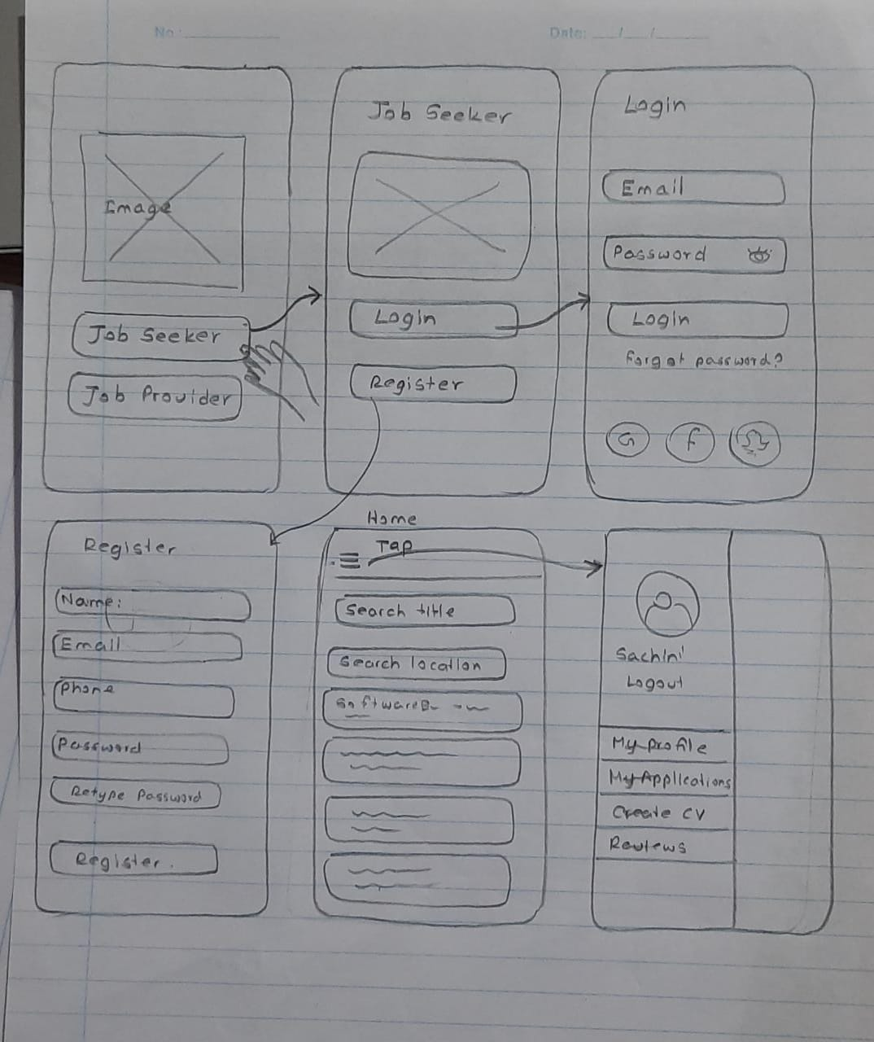

**Member 3 - IT20637064 (R.M.C Anuththara)**

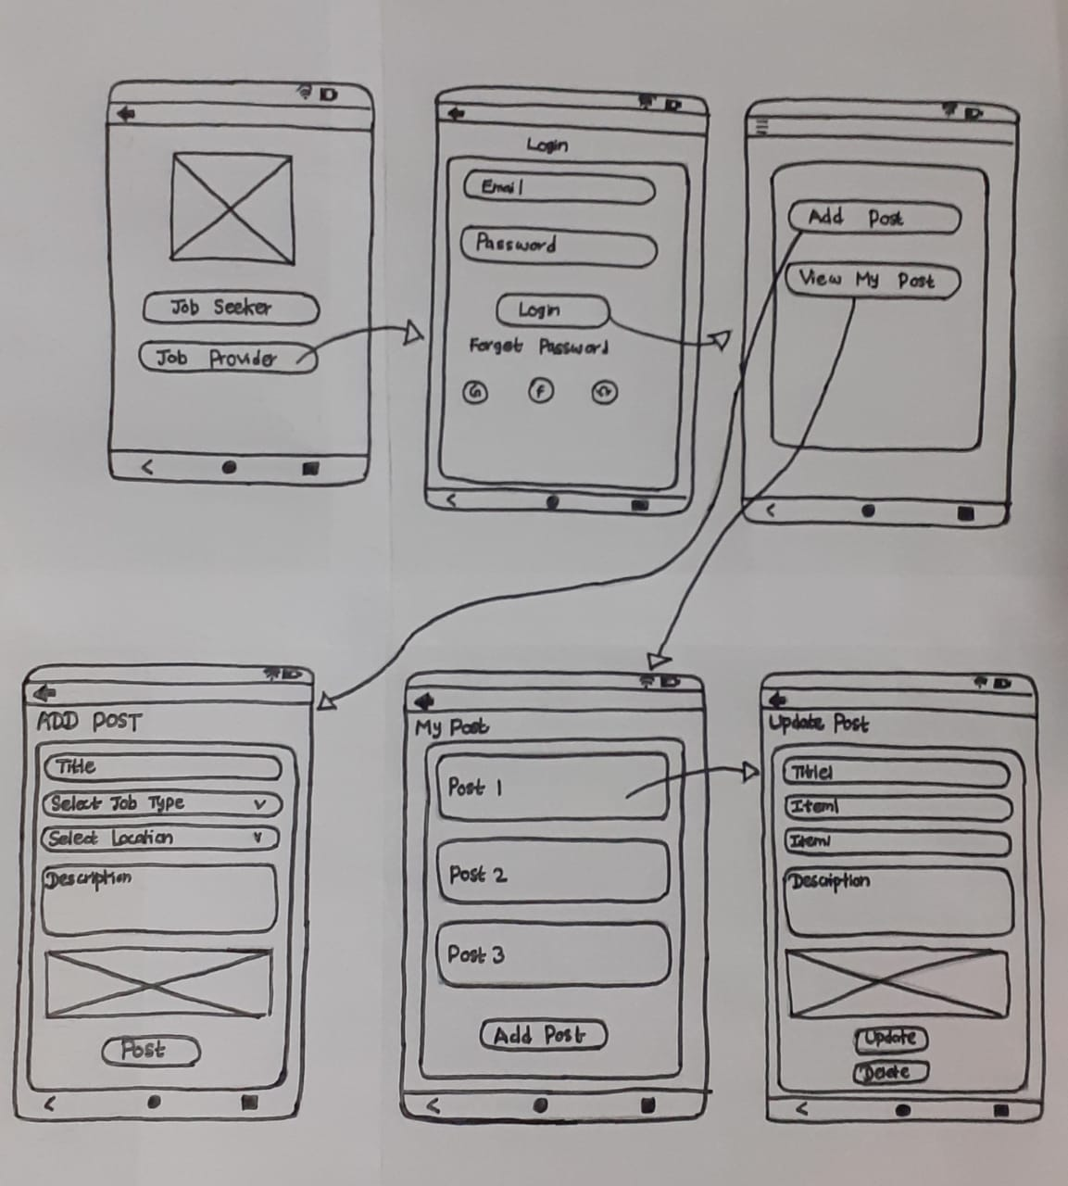**Member 1 -** **IT20642914 (Gamage B.G.A.C)**

**Member 4 - IT20639662 (Navodi P.T.)**

**Member 2 - IT20641092(W.S.S Wijesinha)**

**Member 3 - IT20637064 (R.M.C Anuththara)**

**Member 4 - IT20639662 (Navodi P.T)**

**

**User Interfaces**

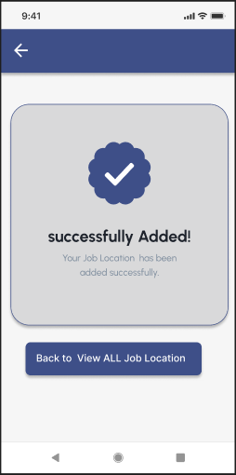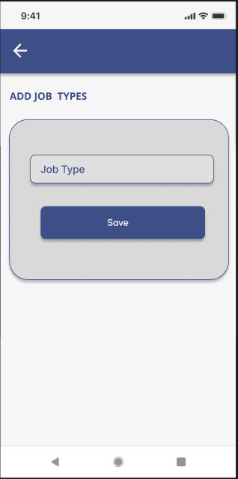**Member 1 -** **IT20642914 (Gamage B.G.A.C)**

**Member 2 - IT20641092(W.S.S Wijesinha)**

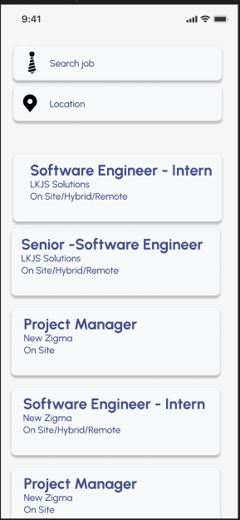

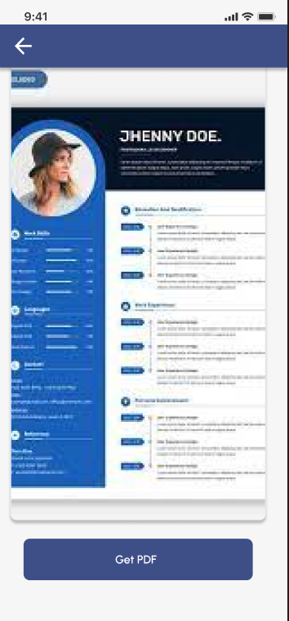

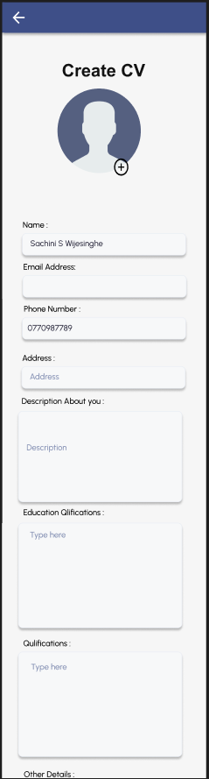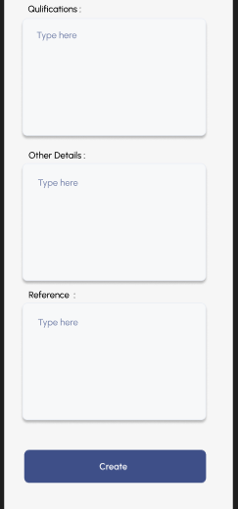

**Member 3 - IT20637064 (R.M.C Anuththara)**

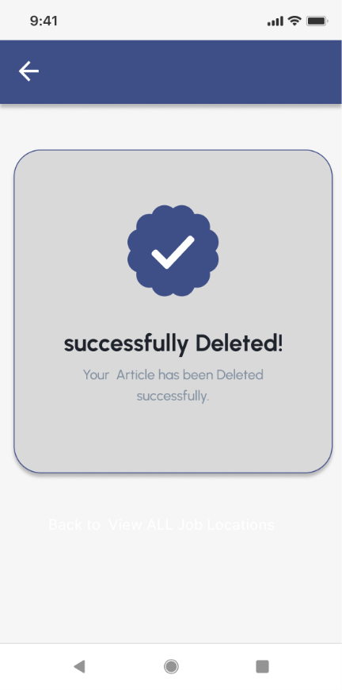

**Member 4 - IT20639662 (Navodi P.T)**

**User feedback for prototypes**

We created google form and get feedback about User interfaces

Link : <https://docs.google.com/forms/d/e/1FAIpQLSed0B-9bw-hYuQtAgYuTTnLxf6HOlMV3STZoir5bpJt99Vr2g/viewform?usp=pp_url>

|  |  |
| --- | --- |
| **Question** | **Answer** |
| 1)Getting feedback about logging screens.  There are two users job seekers and job providers. We created two logins for each user type separately according to the functionality.  What are you thinking as you look at this? There are two logging screens    2)Here we got feedback about job seekers perspective. His user experience. We check about ease about searching jobs according to the job title and job location. And we check user feedback about colors about UIs   What do you think about this attached images?  Mention your suggestions and recommendations  Graphical user interface, application, Teams  Description automatically generated  3) User feedback about navigation menu  What do you think   about user below navigation | Good  Yes, its is better for having two login for both parties  Good  Very attractive  Attractive  It's good  I think both of screen are good enough, they show information wisely  Good  I think those interfaces are user friendly  Nice images  Attractive  Excellent and no recommendations  Hight light card title with another color  its easy to find jobs  Good  There is one this is missing, user logout features  I think Color combination doesn’t match  Good experience  Align the text list correctly  Good, it is better if you add icon for each title |
| 4)Here we check the ui of form.  What do you think about this attached form?  Mention your suggestions and recommendations. | Good  Good  Its is perfect, make it easier to user for applying job  Good option  Its going Keeping simple |
| 5) Here we checked the ui about job consulting  What do you think navigations ,color combination and other thoughts about this attached images  Mention your suggestions and recommendations. | Good  Good  Its quite impressive, blue colour make eye catching  Better  Good look |
| Graphical user interface, text, application  Description automatically generated6)What do you think about this attached images?  Mention your suggestions and recommendations. | Its good,  Good  Color combination is normal  Update button color is lighter  Nice  Yellow dont match your colour theam.  Its good for keeping it separate section for user profile updat |
| 7)What do you think our color theme? | Good  If you can change color theme it will be more attractive.  Excellent  Good  All good but yellow button doesn't match  Impressive |
| 8)What do you think the icons and images we used? | Good  It's matching  Normal  Beautiful icons  Good  Better |
| 9)Overall, are these all flows being convenient? What do you think about button size and colors?   | Its good, and is easy to find user  Good  Normal  Change update button color  In 1 colors are good... 2 size is better  Change the update and delete buttons color  Good, user can easily to click on it |
| 10)What do you think about this attached images?  Graphical user interface, application  Description automatically generatedMention your suggestions and recommendations. | Good  Good  Its quite good.  Excellent  Good, keep it simple |
| Graphical user interface, application  Description automatically generated11)According to the previous user suggestions we added CV Creation function  in our application by applying basic information about users . What do you think about this function. | Yes, its is really good feature  Good  It is really helpful for the user  good  Nice  Good.  Yes, it is good one |

Improvements made

* Used convenient color for the update button
* Used logout link
* Changing the order of navigation
* Changing button sizes

**Prototype**

<https://www.figma.com/file/dspgKIOvxJ4bE444SVgmeX/Untitled?node-id=2%3A2>